Summary
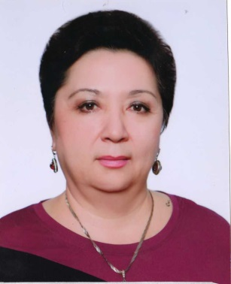 | Full Name (by identity card) | Toktasynova Faruza Abetovna
 | Date of Birth | 29.01.63
 | Gender (male / female) | female
 | Nationality | Kazakh
 | Citizenship | Тhe republic of kazakhstan
 | Mobile phone,  E-mail | 87081914525  rusenados@mail.ru
Place of work: | Kazakh National Research University
Position: | Associate professor
Academic degree, title: | candidate of agricultural sciences. Dr. PD
Education: | Higher, Kazakh Agricultural Institute, 1980-1985, forestry faculty, forestry engineer
Work experience: | 36 years
Overseas internships | Czech Agricultural University in Prague (ČZU), 2018
Activities in the service sector (within and outside the institution): | Consulting services for farmers and forest workers
Scientific activity Head and / or performer of research and development in the Republic of Kazakhstan | Commercialization project contractor
Training of highly qualified personnel | Certificate PC No. 01125 Garden and park construction with the use of Green interiors (online), June, 2020  Certificate PC No. 01345 Suburban forests, (online), August, 2020
Authorship or co-authorship in scientific or development projects | I do not have
Educational and methodical publications: | -Greening of populated areas, methodical guide - A-ata, 2019  -Floriculture, methodical guide for practical training - A-ata, 2019  -Forestry with the basics of dendrology - a methodical guide - A-ata, 2020
Scientific publications | - Monograph "The role of forest plantations in the protection of water resources", 2012  -Choosing assortment of tree species and placing protective vegetation in concrete lining along channels, International Journal of Civil Engineering and Technology (IJCIET) Volume8, Issue12, December 2017, pp.886-894, Article ID: IJCIET_08_12_0  - Forestry- ecological analysis of methods forest reproduction оf forest resources in state forest natural reserve "Yertis Ormany", V international conference «industrial technologies and engineering» Icite – 2017. Shymkent, Kazakhstan October 26-27, 2017 pp.326-334  - Afforestation of the Irtysh-Karaganda Canal named after K.I. Satpayeva, International scientific-practical conference "Actual problems of sustainable development of the forest complex", dedicated to the 70th anniversary of higher forest education in Kazakhstan, volume II, Almaty November 16-17, 2018, pp 232-236  - Study of environmental factors affecting plant growth, morphology and structure of the canopy of pine plantations in the Irtysh region, Materials of the international scientific and practical conference "Innovative approaches to the use of agrobiodiversity in sustainable agricultural development" (September 25-26, 2019 Tashkent, Uzbekistan)  - Introduced trees and shrubs and their general condition in the Shimkent arboretum. Materials of the International Scientific Conference dedicated to the 100th anniversary of Doctor of Biological Sciences, Professor V.I. Tkachenko No. 6, Bishkek, 2019
Incentives and awards: | KazNAU badge "For contribution to the development of agricultural education, science and production", order No. 11 dated 06/26/2018
Knowledge of languages: | English with dictionary
Family composition: | K. Toktasynov - born in 1959 -husband  Toktasynov R - 1984 year of birth - a son  Toktasynov M - 1989 - year of birth - a son

